## Development of DFT model for Amorphous MCM-41 support for metathesis catalysts The aim of this project is to develop a model that could be used to create the three surfaces identified in MCM-41 support material.

# P Geldenhuys, 10800662

## Summary

Ruthenium based olefin metathesis catalyst systems finds very broad application in various industries including pharmaceutical, biotechnology and in the synthesis of speciality polymers. Historically these catalyst systems have been homogenous, leading to high complexity and cost of recovery and regeneration. Industry and research institutions have identified various mesoporous silica materials which could be used as solid supports for the heterogenization of these metal-carbene complex catalyst systems. The heteregenous catalyst system consists of a catalyst adsorbed or bonded to the surface of the amorphous mesoporous support structure. Ideally the catalyst will retain its reactivity and selectivity after adsorbing or bonding to the surface. In order for the catalyst to effectively adsorb or bond to the surface an amorphous mesoporous surface is required with a homologous pore distribution and narrow pore size distribution. The work presented here is a preliminary study into the modelling of the amorphous silica surface for use in the creation of a heterogenous catalyst system.

The aim of this study is to develop a realistic model for rendering alpha quartz amorphous for use as solid mesoporous support for the Grubbs type olefin metathesis catalysts. This model will support parallel laboratory work in the research group focussed on the development of a heterogenous alkene metathesis catalyst system.

Density Functional Theory and Molecular Dynamics modelling of the annealing process of alpha quartz will be performed using the CASTEP module of Material Studio® molecular modelling software created by BIOVA.[1] The results generated will be used to determine optimal conditions for rendering the starting material amorphous and to compare the results with existing practical and molecular modelling results available in literature.

## Introduction

One of the most widely researched and published topics in chemistry in the past two decades is the development of new applications and catalysts for olefin metathesis.[2]

The metathesis reaction involves the cleavage of an alkene carbon-carbon double bond followed by the rearrangement of the alkylidene products to form a product alkene.[3] (*Figure 1)*

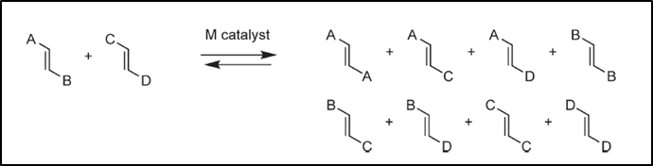

*Figure 1*

A wide variety of categories of metathesis reactions have been identified. The examples shown in (Figure 2) is not exhaustive, but gives an idea of how versatile this family of reactions are.[3]

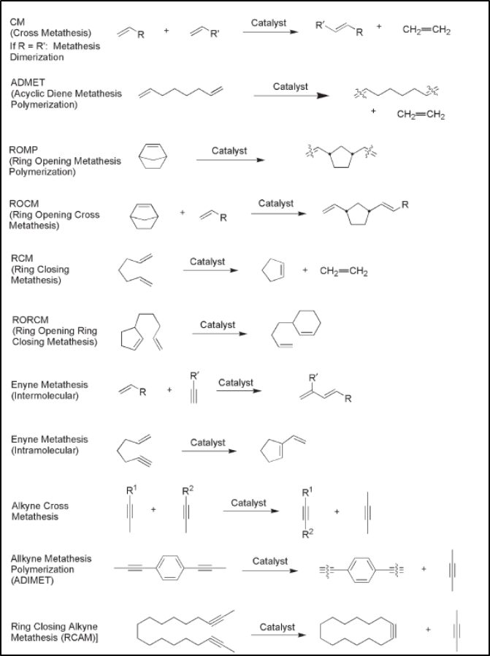

*Figure 2*

Because of this versatility, the olefin metathesis reaction has found wide-spread application in laboratories for the synthesis of unique polymers and research into the synthesis of a wide variety of molecules.[3] The metathesis reaction has led to major advancements in various industries including the synthesis of natural products, pharmaceuticals, nanomaterials, speciality polymers and in the biotechnology industry for the synthesis of steroids and other biological molecules.[4,5,6]

The currently accepted mechanism of olefin metathesis, the Chauvin mechanism, involves reversible cyclo-addition steps involving alkenes and carbene complexes.*[7]* Metal-carbene complexes have thus become the most prominent category of catalysts for olefin metathesis.carbene and carbene complexes. Of these, the Mo based Shrock-catalyst showed high reactivity, but proved to be unstable in certain conditions. This drawback was overcome by the invention of a Ruthenium-Carbene complex catalyst. is.[8] Continued research efforts by various groups have led to several variants of the Grubbs catalysts being developed *(Figure 3)*, each generation improving and expanding on the application of these systems. This has made these catalysts the most widely used and versatile of all the metathesis catalysts available to the industry and research community.[3,9]

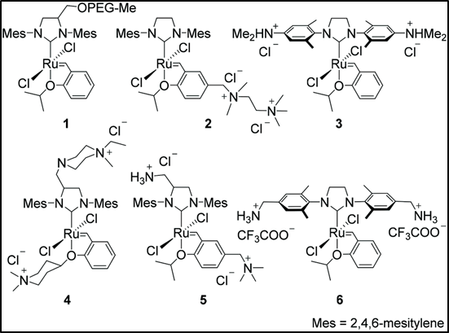

*Figure 3*

The catalyst systems currently in use are mostly homogenous systems and this creates challenges when catalysts need to be recycled and reused. Homogenous systems are also prone to contamination of the reaction product with ruthenium and other transition metal by-products, this is one of the major drawbacks of these catalytic systems for application in the pharmaceutical industry.[10,11]

These challenges have led to various groups initiating studies for the development of heterogenous catalytic systems based on the Grubbs catalysts. These studies have identified several materials as possible solid supports for the catalysts. In particular the MCM-41 group of amorphous silica materials have caught the attention as support materials. This is due to the homologous pore distribution and narrow pore size distribution of these materials.[12]

One.[13,14]Despite this, the cost and time benefits of using a heterogenous catalyst system still outweigh the activity benefits afforded by the homogenous system.

The project will focus on the molecular modelling of MCM-41 hydroxylated amorphous Silica surfaces [15,16]. This project will support a parallel molecular modelling study of the structure and bonding of the Grubbs group of catalysts to the SBA-15 hydroxylated silica surfaces. The properties calculated in the modelling will be used to predict the optimum conditions for the preparation of an amorphous silica bulk which can be used as

## Aim

The aim of this project is the development of method to creating an amorphous SiO2 bulk structure. And to develop a model that could be used to create the three surfaces identified in MCM-41 support material,

## Method

An alpha quartz (space group 180) crystal structure was obtained from Materials Studio’s structure repository. A (3x3x3) super-cell was built.(Figure 4)

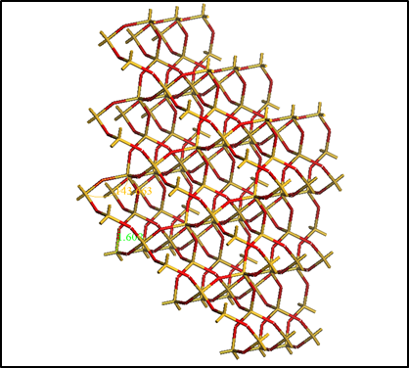

*Figure 4*

This super-cell (bulk) was submitted to an energy calculation. The following properties were calculated for the super-cell.

1. Energy
2. Density of states
3. Band Structure
4. Orbitals
5. Bond lengths and bond angles

The next step was to create a model from which a MCM-41 mesoporous surface can be cut. To accomplish this the (3x3x3) super cell created previously was submitted to dynamics studies using Materials Studio’s CASTEP module.[15,16]

The dynamics study entailed heating (to create a liquefied sample) the super cell that was created previously to 4000K, 5000K and 6000K respectively, using a NVT ensemble. The heating was done in 50, 100 and 150 steps with a constant time step of 1 fs using a Nose thermostat. The structure obtained at each temperature was then quenched to 1K in 2 steps with a constant time step of 1 fs using a Nose thermostat. The resulting structures was annealed by heating the resulting structures to 1000K using the same settings for each structure as that used in the initial heating. The resulting structures was then cooled down to 300 K using the same time step setting as used during the melting step for each structure. This work procedure is outlined in Table 1

|  |  |  |  |  |  |
| --- | --- | --- | --- | --- | --- |
| Calculation 1 |  |  |  | Annealing | |
|  | Melting | Quenching | Annealing | Cooling |
| Temperature (K) | 4000 | 1 | 1000 | 300 |
| Steps | 50 | 2 | 50 | 50 |
| Calculation 2 |  |  |  | Annealing | |
|  | Melting | Quenching | Annealing | Cooling |
| Temperature (K) | 4000 | 1 | 1000 | 300 |
| Steps | 100 | 2 | 100 | 100 |
| Calculation 3 |  |  |  | Annealing | |
|  | Melting | Quenching | Annealing | Cooling |
| Temperature (K) | 4000 | 1 | 1000 | 300 |
| Steps | 150 | 2 | 150 | 150 |
| Calculation 4 |  |  |  | Annealing | |
|  | Melting | Quenching | Annealing | Cooling |
| Temperature (K) | 5000 | 1 | 1000 | 300 |
| Steps | 50 | 2 | 50 | 50 |
| Calculation 5 |  |  |  | Annealing | |
|  | Melting | Quenching | Annealing | Cooling |
| Temperature (K) | 5000 | 1 | 1000 | 300 |
| Steps | 100 | 2 | 100 | 100 |
| Calculation 6 |  |  |  | Annealing | |
|  | Melting | Quenching | Annealing | Cooling |
| Temperature (K) | 5000 | 1 | 1000 | 300 |
| Steps | 150 | 2 | 150 | 150 |
| Calculation 7 |  |  |  | Annealing | |
|  | Melting | Quenching | Annealing | Cooling |
| Temperature (K) | 6000 | 1 | 1000 | 300 |
| Steps | 50 | 2 | 50 | 50 |
| Calculation 8 |  |  |  | Annealing | |
|  | Melting | Quenching | Annealing | Cooling |
| Temperature (K) | 6000 | 1 | 1000 | 300 |
| Steps | 100 | 2 | 100 | 100 |
| Calculation 9 |  |  |  | Annealing | |
|  | Melting | Quenching | Annealing | Cooling |
| Temperature (K) | 6000 | 1 | 1000 | 300 |
| Steps | 150 | 2 | 100 | 100 |

*Table 1*

Using a GGA-PBE functional and DNP basis set, the system energy, as well as the following properties was calculated for each result set (structure).

* + Energy
  + Bond lengths and bond angles
  + Density of states
  + Band structure
  + Electron density difference
  + Orbitals

The results obtained for the amorphous structure (Figure 5) was compared to the values for the initial crystal structure as well as published experimental and theoretical data.

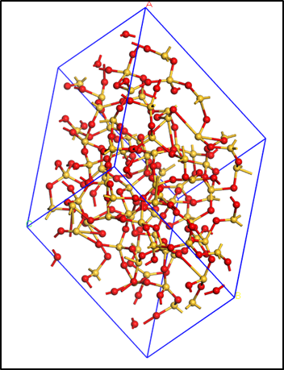

*Figure 5*

## Results and discussion

Result files from the Material Studio software were downloaded and interpreted.

The values for the measured parameters which are discussed here for the super-cell that was built as staring material is shown in Table 2

|  |  |  |
| --- | --- | --- |
|  | Value |  |
| Bond Angle | 143.663 | deg |
| Bond Length | 1.609 | A |
| Energy | -79498.14133 | eV |
| Band Gap | 5.823 | eV |

*Table 2*

### Energy

The energy values for the various steps of the simulation was plotted and is shown in

Figure 6. The energy calculated for the crystalline super-cell is used as a starting point

The energy evolution for the specific temperature conditions are shown in Figures 7-9

*Figure 6*

*Figure 7*

*Figure 8*

*Figure 9*

From these energy curves it can be deducted that the system has the most energy after the being heated to 6000K in 150steps of 1fs. The subsequent quenching has little impact on the energy of the system, but does however return the system to a solid state. The conclusion can be drawn that for this set of calculations that would be the solid structure with the highest level of disorder in the system and thus the most amorphous. This is confirmed when the energy for the various melting and quenching steps are plotted against each other. (Figure 10)

*Figure 10*

### Band Gap

Another property of the system that serves as an indicator of the reactivity and level of disorder is the band gap. The gap refers to the energy level in molecular orbitals seperating the HOMO and the LUMO.

In the calculations it is noted that the band gap reaches its lowest, and thus most reactive level when the material is heated to 6000K. Table 3 lists the band gaps for each structure that was calculated.

|  |  |  |  |  |
| --- | --- | --- | --- | --- |
| Structure | Melting | Quench | Anneal | Cooling |
| 4000-50 | 0.236 | 0.251 | 4.347 | 3.412 |
| 4000-100 | 0.3 | 0.322 | 4.801 | 5.187 |
| 4000-150 | 1.35 | 1.403 | 4.393 | 5.179 |
| 5000-50 | 0.04 | 0.039 | 2.294 | 3.178 |
| 5000-100 | 0.072 | 0.168 | 0.511 | 3.026 |
| 5000-150 | 0.272 | 0.285 | 3.047 | 3.798 |
| 6000-50 | 0.048 | 0.049 | 0.224 | 0.165 |
| 6000-100 | 0.02 | 0.014 | 0.08 | 0.093 |
| 6000-150 | 0.042 | 0.04 | 0.684 | 0.725 |

*Table 3*

The value highlighted in green after the quenching of a structure heated to 600K in 100 steps shows the minimum in this series.

Further evidence to support the conclusion that the highest reactivity and most amorphous solid is formed when the initial bulk is heated to 6000 is found when the values for the melting and quenching steps are plotted separately from the values for the annealing steps. Figures 11-12

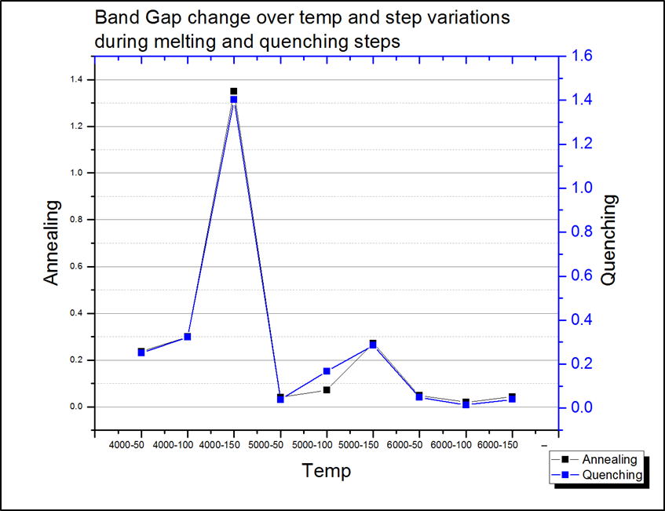

*Figure 11*

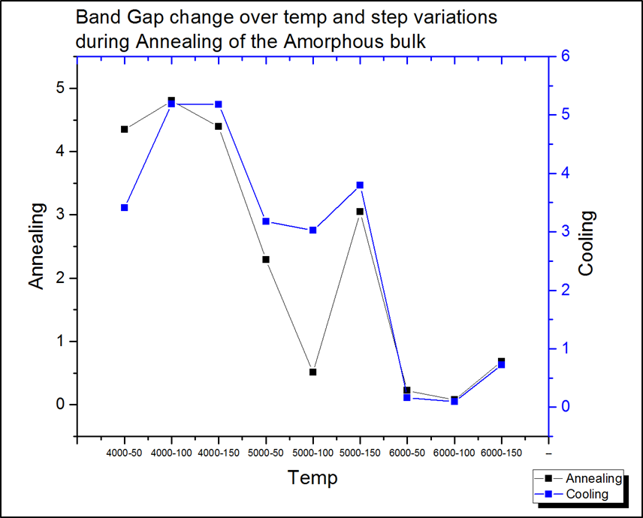

*Figure 12*

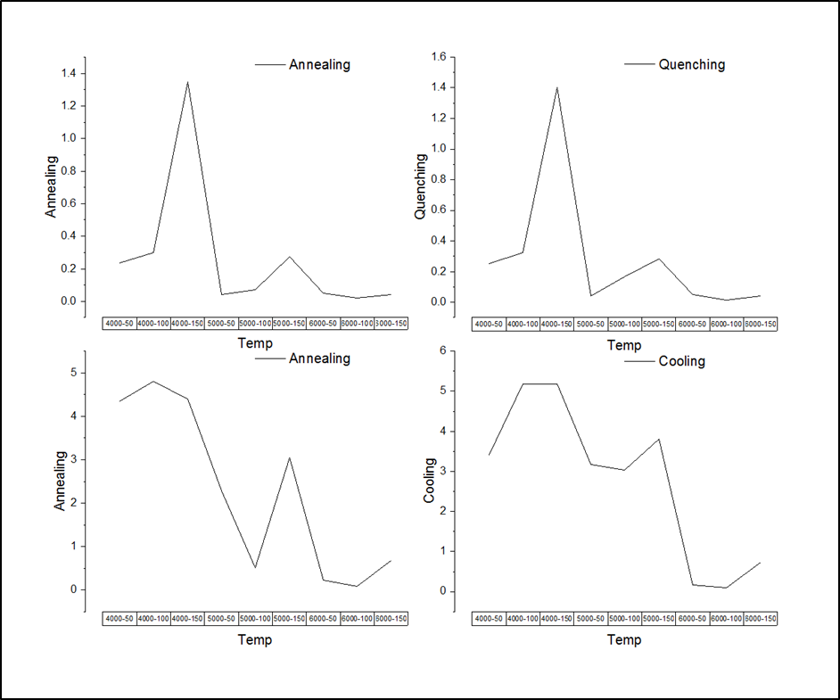*Figure 13*

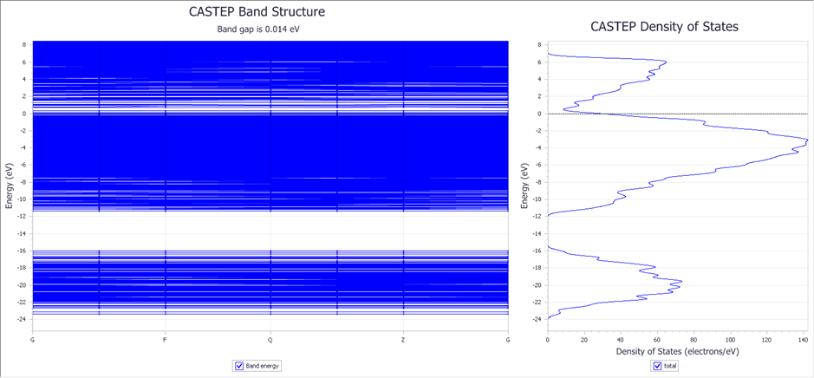*Figure 14*

### Bond angle

One of the properties of amorphous solids is that the spread of bond angles and bond lengths are widely distributed. Crystalline solids however show a very narrow distribution of values. The level of disorder can therefore be evaluated at the hand of the variation in the values of the bond angles and bond lengths as well as the deviation from the value in the original crystalline solid. Bond angles and lengths were measured after each step of the process to evaluate the level of disorder in the system. The values were compared with the original bonds as found in the supercell. Figures 15-17 shows the average change of bonding angles in the resulting structures after each step during the initial melting of the crystalline solid. Tables 4 and 5 provides a summary of the bond angle deviations that were observed.

*Figure 15*

*Figure 16*

*Figure 17*

|  |  |  |  |  |  |
| --- | --- | --- | --- | --- | --- |
| Steps | Alpha | Melt | Quench | Anneal | Cool |
| 4000-50 | 143.663 | 149.987 | 149.934 | 144.4 | 149.096 |
| 4000-100 | 143.663 | 163.328 | 163.24 | 145.528 | 154.237 |
| 4000-150 | 143.663 | 131.618 | 131.664 | 145.603 | 128.512 |
| 5000-50 | 143.663 | 124.438 | 124.417 | 153.804 | 146.072 |
| 5000-100 | 143.663 | 124.483 | 124.519 | 149.817 | 148.212 |
| 5000-150 | 143.663 | 113.593 | 113.662 | 134.388 | 113.593 |
| 6000-50 | 143.663 | 116.921 | 117.017 | 150.267 | 117.017 |
| 6000-100 | 143.663 | 108.654 | 108.725 | 120.409 | 125.495 |
| 6000-150 | 143.663 | 154.692 | 154.609 | 127.796 | 129.45 |

*Table 4*

|  |  |  |  |  |
| --- | --- | --- | --- | --- |
|  | Melt | Quench | Anneal | Cool |
| 4000-50 | 6.324 | 0.053 | 5.534 | 4.696 |
| 4000-100 | 19.665 | 0.088 | 17.712 | 8.709 |
| 4000-150 | 12.045 | 0.046 | 13.939 | 17.091 |
| 5000-50 | 19.225 | 0.021 | 29.387 | 7.732 |
| 5000-100 | 19.18 | 0.036 | 25.298 | 1.605 |
| 5000-150 | 30.07 | 0.069 | 20.726 | 20.795 |
| 6000-50 | 26.742 | 0.096 | 33.25 | 33.25 |
| 6000-100 | 35.009 | 0.071 | 11.684 | 5.086 |
| 6000-150 | 11.029 | 0.083 | 26.813 | 1.654 |

*Table 5*

Specific angles within the crystalline solid was identified and measured specifically after each of the steps. The bond angle values as well as the absolute change in angle after the steps are shown in Figures 18-19

*Figure 18*

*Figure 19*

The bond angle deviations observed compares very well to published results referring to deviations of bond angles in amorphous silica solids.

A graphical representation of this is shown in Figure 20 as published by Bhattarai et al and Izumi et al. [15,17]

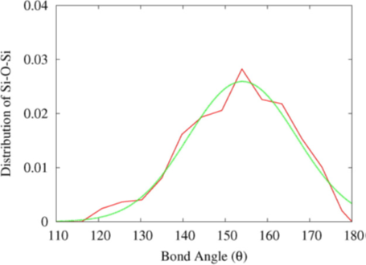

*Figure 20*

### Bond lengths

The Si-O bond lengths in the alpha quartz varies in amorphous solids. The Si-O bond length in crystalline alpha quartz is equal to 1.609 A

The deviation from the initial bond length for six randomly chosen bonds in each structure after the initial heating of the structure is summarized in Table 6

|  |  |  |  |  |  |  |
| --- | --- | --- | --- | --- | --- | --- |
|  | 1 | 2 | 3 | 4 | 5 | 6 |
| Alpha Quartz | 1.609 | 1.609 | 1.609 | 1.609 | 1.609 | 1.609 |
| 4000-50 | 1.623 | 1.668 | 1.803 | 1.635 | 1.992 | 1.828 |
| 4000-100 | 1.714 | 1.644 | 1.874 | 1.609 | 1.636 | 1.569 |
| 4000-150 | 1.741 | 1.623 | 1.874 | 1.618 | 1.714 | 1.539 |
| 5000-50 | 1.494 | 2.136 | 1.562 | 1.687 | 1.832 | 1.558 |
| 5000-100 | 1.665 | 2.254 | 1.463 | 1.628 | 1.737 | 1.452 |
| 5000-150 | 1.627 | 1.526 | 1.857 | 1.806 | 1.737 | 1.621 |
| 6000-50 | 1.796 | 1.709 | 1.784 | 1.612 | 1.766 | 1.681 |
| 6000-100 | 1.692 | 1.677 | 1.589 | 1.552 | 1.742 | 1.606 |
| 6000-150 | 1.645 | 1.721 | 2.771 | 1.797 | 1.809 | 2.114 |

*Table 6*

Bond lengths deviations reported by *Izumi et al,* corresponds to these results, indicating that the methodology for obtaining an amorphous solid is correct.[15]

## Conclusion

The work presented here served as a preliminary study into the methodology used for rendering crystalline alpha quartz amorphous. From the data that was collected and comparisons with published values it is clear that the method used is the most effective to achieve an amorphous solids.[15] These amorphous materials can be used to prepare the MCM-41 for the adsorption and bonding studies of the Grubbs olefin metathesis catalysts. The results obtained shows that the level of disorder in the resulting amorphous structure increases linearly with higher temperature and longer time steps. It is therefore suggested that further work is conducted. In this further work, a higher temperature and more time steps should be incorporated to determine if this will increase the amorphous character of the resulting solid. From the results obtained it is also deducted that an amorphous solid is obtained directly after the initial melting and quenching steps. Further work should therefore be focussed on optimizing conditions during these two steps

A possible work flow is shown in Table 7

|  |  |  |  |
| --- | --- | --- | --- |
| Calculation 1 |  |  |  |
|  | Melting | Quenching |
| Temperature (K) | 6000 | 300 |
| Steps | 500 | 2 |
| Calculation 2 |  |  |  |
|  | Melting | Quenching |
| Temperature (K) | 6000 | 300 |
| Steps | 1000 | 2 |
| Calculation 3 |  |  |  |
|  | Melting | Quenching |
| Temperature (K) | 6000 | 300 |
| Steps | 10000 | 2 |
| Calculation 4 |  |  |  |
|  | Melting | Quenching |
| Temperature (K) | 6500 | 300 |
| Steps | 100 | 2 |
| Calculation 5 |  |  |  |
|  | Melting | Quenching |
| Temperature (K) | 6500 | 300 |
| Steps | 1000 | 2 |
| Calculation 6 |  |  |  |
|  | Melting | Quenching |
| Temperature (K) | 6500 | 300 |
| Steps | 10000 | 2 |
|  | Melting | Quenching |
| Temperature (K) | 6000 | 1 |
| Steps | 150 | 2 |

*Table 7*

References

1. Material Studio ref
2. J W Herndon, 2007, The chemistry of the carbon–transition metal double and triple bond: Annual survey covering the year 2005, *Coordination Chemistry Reviews,*251(9-10): 1158-1258
3. Jordaan, M., *Experimental and Theoretical investigation of New Grubbs-type Catalysts for the Metathesis of Alkenes.* p. 413. (1)
4. K. Żukowska, A. Szadkowska, K. Grela, 2013, 6.05 - Olefin Metathesis, Reference Module in Chemistry, Molecular Sciences and Chemical Engineering, *Comprehensive Inorganic Chemistry II (Second Edition),* Volume 6, 2013, Pages 105-126
5. Kongparakul, S. Ng, F.T.T. Rempel, G.L. 2011. Metathesis hydrogenation of natural rubber latex. *Applied Catalysis A: General*, 405 (2011): 129– 136
6. Morzycki, J.W. 2011. Application of olefin metathesis in the synthesis of steroids, *Steroids,* 76 (2011) 949– 966
7. Herrison, J. L.; Chauvin, Y. 1971. Makromolecular. Chemistry. 141: 161–176
8. Grubbs, R.H. 2004. Olefin Metathesis *Tetrahedron*, 60(34): 7117-7140
9. Sambasivarao K. Mirtunjay K.D. 2012. *Tetrahedron* 68(2): 397-421
10. Pastvaa, J., Cejkaa, Zilkováa, N., Mestekb, O. Rangusc, M., Balcara, H. 2013. Hoveyda–Grubbs first generation type catalyst immobilized onmesoporous molecular sieves, *Journal of Molecular Catalysis A: Chemical* 372 (2013): 35– 43
11. Staub*,*H., Kleitz, F*.,*Frédéric-Georges Fontaine*,* F.G*.,* 2013, *Microporous and Mesoporous Materials* 175 (2013) 170–177
12. Shinde, T., Zilkova, N., Hankova, V., Balcar, H, 2013, *Catalysis Today* 179 (2012): 123– 129
13. Thielemann, J.P. 2011. Pore structure and surface area of silica SBA-15: influence of washing and scale-up. *Journal of. Nanotechnology*,. 2: 110-8. (2)
14. Balcar, H. and J. Čejka, Mesoporous molecular sieves as advanced supports for olefin metathesis catalysts. *Coordination Chemistry Review*., 2013. 257: 3107-3124. (3)
15. Izumi, S.,Hara, S., Kumagai, T., Sakai, S., 2004, Classification of amorphous-silicon microstructures by structural parameters: molecular dynamics study. *Computational Material Science*. 31: 258-268. (4)
16. Ugliengo, P., et al. 2008, Realistic models of hydroxylated amorphous silica surfaces and MCM-41 mesoporous material simulated by large-scale periodic B3LYP calculations. Adv. Mater., 20: 4579-4583. (5)
17. Bhattarai, B., Drabold, B.A., 2016, Vibrations in amorphous silica, *Journal of Non-Crystalline Solids*, 439 (2016): 6–14